Kandula,Sai Raj Kiran

S525020@mail.nwmissouri.edu

Abstract

Paperplane is an intuitive travel planning app that allows you to plan a trip with just a few simple taps.

UI Design Document

Paperplane Website

**Document Approval**

|  |  |  |  |
| --- | --- | --- | --- |
|  | **Name** | **Date** | **Signature** |
| Prepared by | Sai Raj Kiran Kandula | 10/27/2016 |  |
| Checked by |  |  |  |
|  |  |  |  |

**Change control History**

|  |  |  |  |
| --- | --- | --- | --- |
| **Version** | **Date** | **Author** | **Description** |
| 1.0 | 10/28/2016 | Sai Raj Kiran Kandula | Detailed design of the website. |
|  |  |  |  |
|  |  |  |  |

**Contents**

**1.** **Introduction** 1

**1.1.** **Purpose** 1

**1.2.** **Definitions, Acronyms, and Abbreviations** 1

**1.3.** **Scope** 1

**1.4.** **References** 1

**1.5.** **Product Functions** 1

**2.** **Graphical Interface Design** 2

**3.** **Structure and Navigation** 3

**3.1.** **Login/Sign Up** 4

**3.1.1.** **Login** 4

**3.1.2.** **Registration** 5

**3.2.** **Plan** 7

**3.2.1.** **Save Itinerary** 7

**3.3.** **Contact Us** 8

**3.4.** **Top Places to Visit** 9

**3.5.** **Subscription to News Letter** 10

**3.6.** **Testimonials** 10

**3.7.** **Settings** 11

# **Introduction**

## **Purpose**

Paperplane website aims to provide travel planning service to users across the world.

## **Definitions, Acronyms, and Abbreviations**

|  |  |
| --- | --- |
| **Abbreviation** | **Definition** |
| Itinerary | A planned route or journey |
| HTML | Hyper Text Markup Language |
| CSS | Cascading Style Sheet |
| JS | JavaScript |

## **Scope**

Website design may not be exactly similar to design on the app. Database and server management will not be taken care of. The emphasis is only on front end development. The main aim of this project would be the development of a website which supports desktop, laptop, and mobile browsers.

## **References**

*There is an android application regarding Paperplane travel so we took that application as a reference and building our website.*

## **Product Functions**

Pick a destination and enter the duration of stay, Paperplane will plan a personalized itinerary for you automatically, so no more hassle of scheduling and planning. It's free, download Paperplane Android app and start exploring the world now.

Powerful features:

- Automatically plan a personalized trip with just a few taps  
- Calculate an optimized route to get the most out of your limited travel time.  
- Discover attractions in the city, travel like a local.  
- Automatically search for accommodations that are convenient and suit your style.  
- Travel with Paperplane without using the internet.  
- With detailed transit navigation, Paperplane is your travel companion.  
- No more hassle of scheduling and planning. Relax and enjoy your trip with Paperplane.

# **Graphical Interface Design**

This section presents the graphical user interface of the NSW Web application that will have the form of a lightweight web application, where all functionalities are grouped visually and logically into thematic units.

The design provides for a responsive site that will work on both desktop and mobile tablet devices. The sections that follow contain mock views of a selection of the most important aspects of the GUI, along with textual descriptions of their purpose and contents.

The design foresees the development of the web application using the following HTML templates:

* HTML 5
* Bootstrap
* CSS 3
* JS

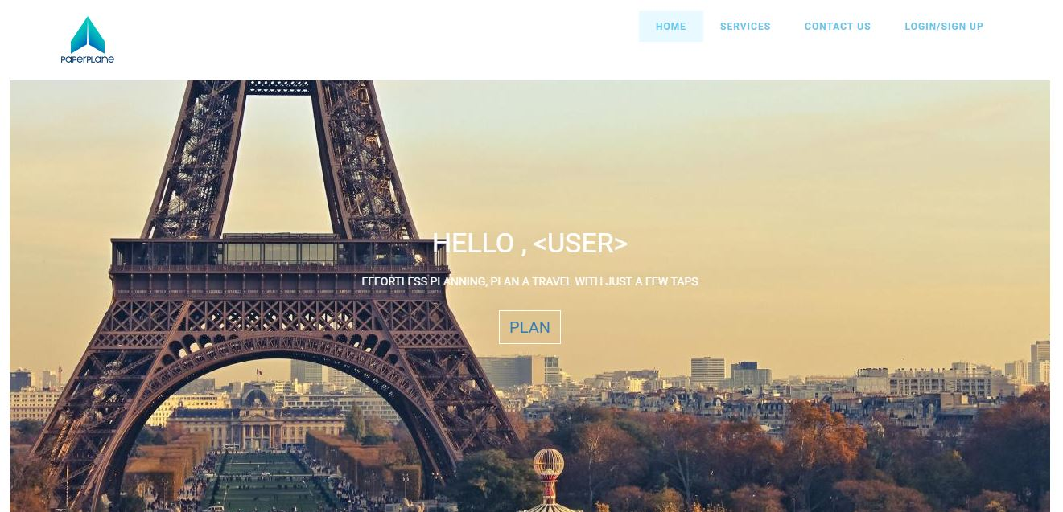

Fig 1.0: Home

# **Structure and Navigation**

The overall structure of the application is relatively simple, as shown in the following diagram.

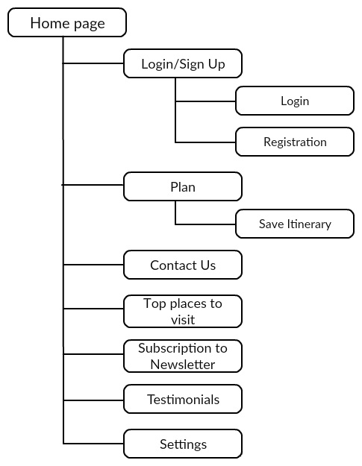

Fig 2.0: Structure

There are seven primary elements on the site, and each of these may be accessed directly from the main page.

**Navigation:**

The user can navigate to all the major elements directly from the home page.

## **Login/Sign Up**

### **Login**

This section describes the “Login” page. The main component is the login form, where the user needs to provide the credentials in order to be authorized to use the web application.

* **Username and password credentials**: Log in by providing username and password given during the registration of an account.
* **Using social networking sites like Facebook:** Another way of logging in to the application is by using Facebook where he needs to provide the appropriate username and password for immediate login.

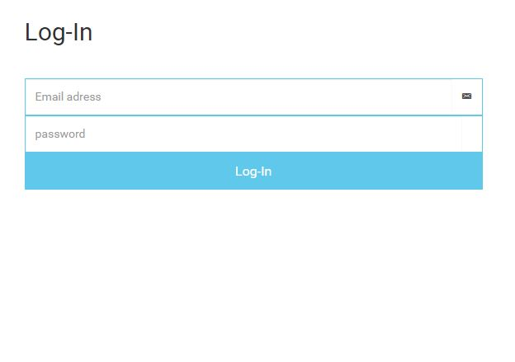

Fig 3.1.1: Login

**Input:**

* The user can enter user id and password if the user was already registered with Paperplane.
* If the user likes to login with Facebook, he/she should enter Facebook credentials.

**Processing:**

* If the user using Facebook to login to the website it will Invoke Facebook API to log in.
* If the user enters credentials that are registered in Paperplane, it will check in the database and give access to the website if the user gets authorized.

**Output:** Displays the places on the home page filled with some famous destinations.

* Once the user successfully logs in, There would pop out a series of questions asking the user to give a rating from 1-5 based upon their interest.

Untitled Diagram

**Error handling**: Denies the entry when improper username or password is given. Checks for the presence of Facebook account and gives the entry.

### **Registration**

This section describes the “Registration” page. The main component is the registration form, where the user needs to provide the credentials in order to be authorized to use the web application.

The necessary credentials required are

* First name
* Last name
* Email id and
* Password of 6 characters length

**Inputs:** All the necessary credentials

* First name – string of length with 1 to 16 characters, cannot be empty.
* Last name- string of length with 1 or10 characters, cannot be empty.
* Email id- for this we are using a regular expression which has a limitation of symbols, numbers, and alphabets.
* Password – should be a minimum of 6 characters.

They are stored using HTTPS which automatically encrypts and store in the database.

* For Sign in through Facebook directly we will use Facebook API

**Processing:**

* Checks whether all the credentials were given in proper format.
* If the username is already used, it will give a pop-up that username already exists, asking the user to provide a different username.
* It also might check for password sequence and its length.
* It must give a pop up saying password length is too short when the password of fewer than 6 words length is given as input.
* When the first name or last name is not given, there would pop up a message saying that last name or first name must be given.

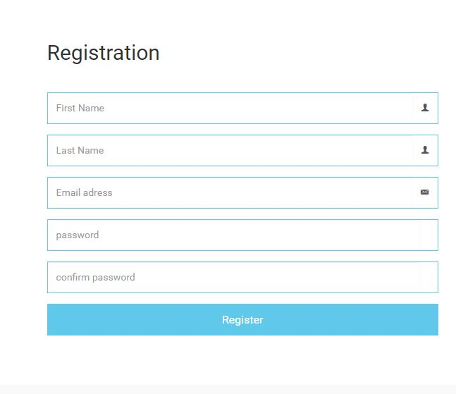

Fig 3.1.2: Registration

**Output:** Creation of a new account in the Paperplane application and user will be redirected to the website.

**Error handling:**

* If the user credentials don’t match with the actual details an error will be prompted to the user stating the error, thereby providing the user how to handle the error to login into his/her account.
* Similarly, if the user wants login using his Facebook credentials, he/she must enter valid credentials if not an error will be prompted to the user stating the error.

## **Plan**

When the user wants to plan a trip he can choose a destination from home page or he can click on Plan button and will be directed to a page where he can search for a place.

**Inputs:**

* Users can select the destination he/she want to go and dates of stay.
  1. Enter the City where the user likes to travel.
  2. Enter departure date and return date.
  3. Enter arrival time and departure time.

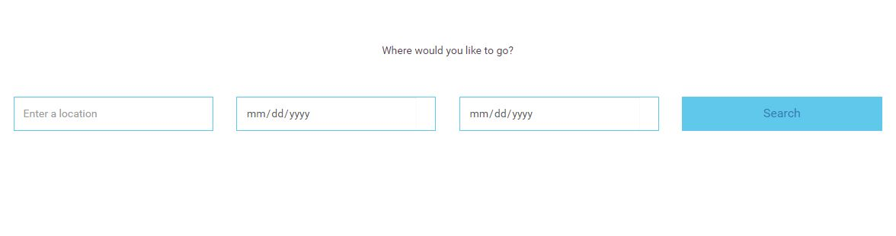

Fig 3.2: Plan

**Processing:**

* The inputs supplied by the user will be sent to the server to plan an itinerary.

**Outputs:**

* After clicking search, the page will be redirected to the itinerary page where the user can see the route map and itinerary plan for that place with appropriate time and date constraints.

### **Save Itinerary**

When the user wants to save a trip he/she must log in with the valid credentials.

**Inputs:**

After generating itinerary a save button will be displayed, now user can click on that button to save the itinerary for future reference or use.

**Processing:**

* The inputs supplied by the user will be sent to the server and save the plan in the user account.

**Outputs:**

* The saved itinerary will be displayed in my trips page.

**Error Handling:**

Displays an error message based on the error code from the server.

## **Contact Us**

This section describes the “Contact Us”. The main component is the contact us form, where the user can ask questions, inform concerns or provide feedback to the Paperplane team.

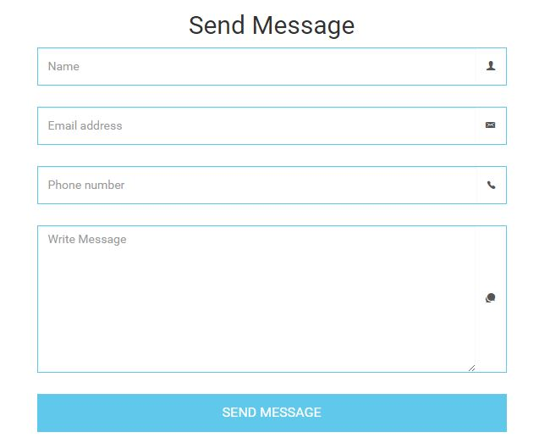

Fig 3.3: Contact Us

The necessary credentials required are

* Name
* Email id and
* Phone number
* Message

**Inputs:** All the necessary credentials

* Name- must be a string, cannot be empty.
* Email id- for this we are using a regular expression which has a limitation of symbols, numbers, and alphabets.
* Message- Any text including numbers and special characters.

**Processing:**

* Checks whether all the credentials were given in proper format.
* It also might check for Email sequence.
* It must give a pop up saying Valid email must be given with @ symbol.
* When the Name field is not filled, there would pop up a message saying that Name must be given.

**Output:** A feedback message something like “We received your concern, Our team will contact you soon”, will be displayed.

**Error handling:**

Displays an error message based on the error code from the server.

## **Top Places to Visit**

This section describes the “Top places to visit”. The main component is Top places, where the user can see top places to travel in the world.



Fig 3.4: Top Places to Visit

**Input:**

* Click on the image (place).

**Processing:**

* The page will be redirected to plan in section 3.2 and location field is filled with the selected location.

**Output:**

* The page will be redirected to plan in section 3.2.

## **Subscription to News Letter**

This section describes the “Newsletter subscription”. The main component is subscription field.

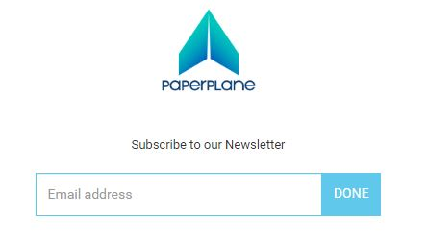

Fig 3.5: Subscription to Newsletter

**Input:**

* Enter a valid email address.

**Processing:**

* The email address will be saved in Paperplane server.

**Output:**

* Feedback message like “Thanks for subscribing to our newsletter” will be displayed.
* Latest updates and regular news will be emailed to the provided email address.

## **Testimonials**

This section describes the “Testimonials”. The main component is listing few latest reviews by the users.

**Input:** No Input

**Output:**

* Latest user reviews will be displayed.

## **Settings**

The settings page is to set the user’s preferences. The user can set preferences and can change date and time formats.

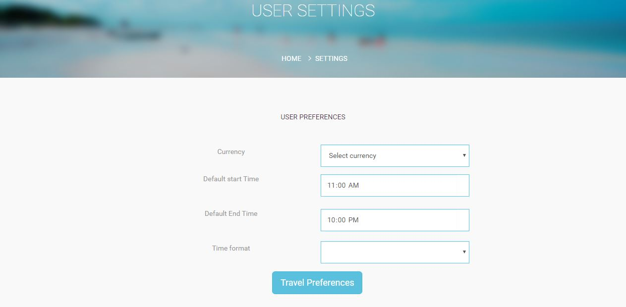

Fig 3.7 (a): Settings

**Input:**

* Time format: User has a choice to select 12 hour or 24 hour time format.
* Currency: User can select the currency.
* Default start and end time: User can select start and end time of the day.
* Travel preferences: User can set the level of interest in it.
* Social networking links: user can go to Paperplane official account on Twitter, Facebook, and Instagram.

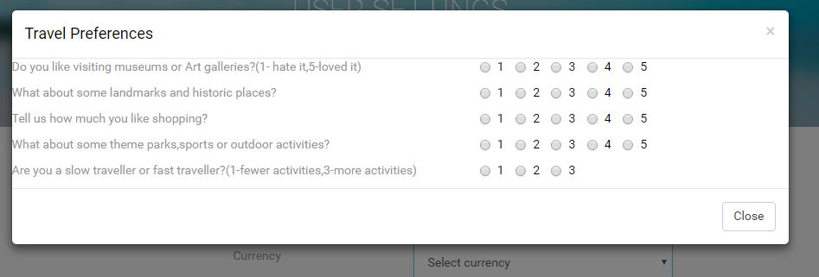

Fig 3.7 (b): Settings

**Processing:**

* Go to home page.
* Click ‘Settings’ button on the home page.
* A list of options like Currency, Default Start Time, and Default End time, Time Format, Travel preferences will be displayed.
* The user can set his/her preferences/interests and their rating from 1 to 5 in ‘Travel Preferences’. The plan will display the places basing on user interests.
* The user can logout from his account by clicking on ‘Logout’.
* In ‘Currency’, user can select the currency form the dropbox.
* In ‘Default Start Time’ and ‘Default End time’ options user can set his/her start and end times of a day. So that the application will plan events within those day limits. By default the application will set to 10 am as start time and 7 pm as the end time.
* In ‘Time Format’, the user can set the time format as 12 hours or 24 hours.

**Output:** Saved changes are visible to the user in the settings menu if we made any changes in settings.

**Error handling:** Displays an error message based on the error code from the server.